MAP to Laboratory for Nanoelectronics and Spintronics,
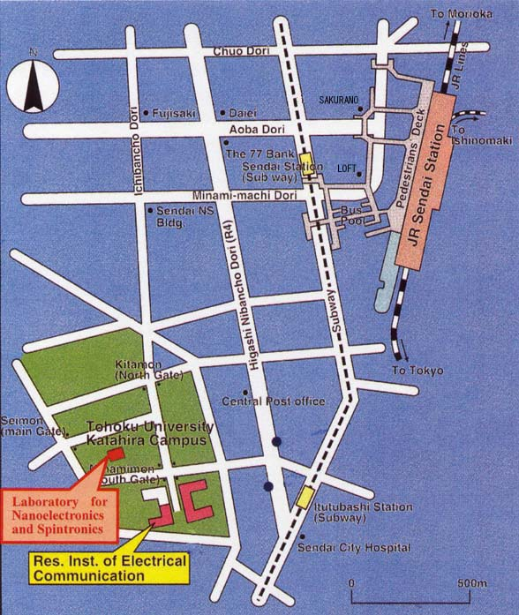
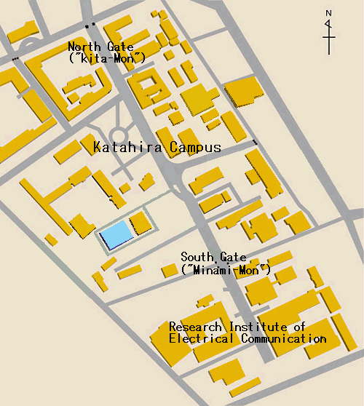
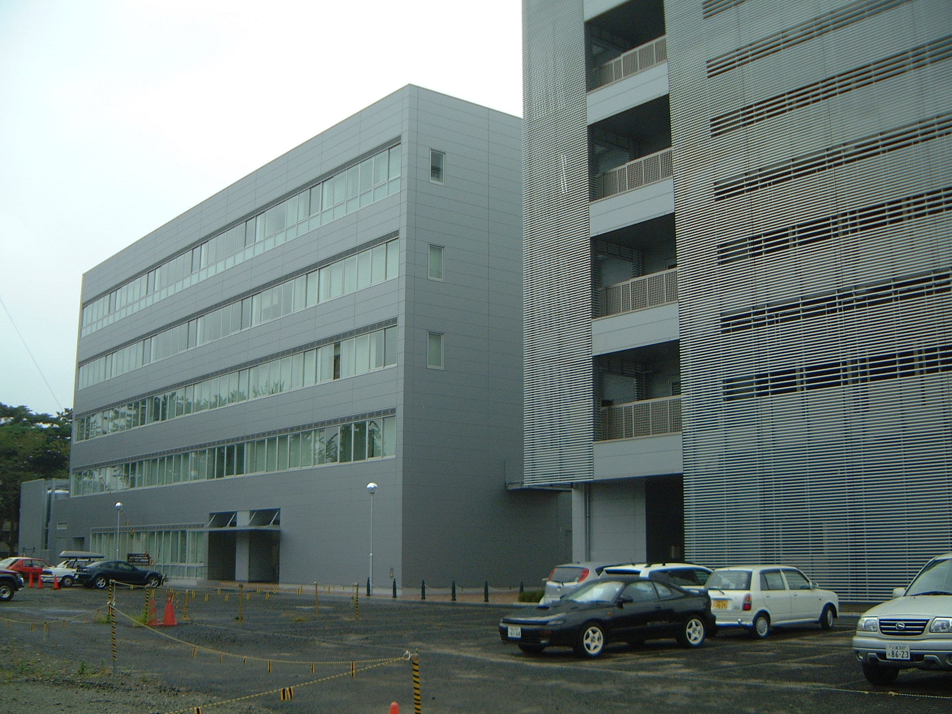
Research Institute of Electrical Communication, Tohoku-Univ., Sendai, Japan
Hotel Bel Air
(Nearest Hotel)
Laboratory for Nanoelectronics and Spintronics
Laboratory for Nanoelectronics and Spintronics
Laboratory for Nanoelectronics and Spintronics

Detailed Map

