MAP to Laboratory for Nanoelectronics and Spintronics,
Research Institute of Electrical Communication, Tohoku-Univ., Sendai, Japan
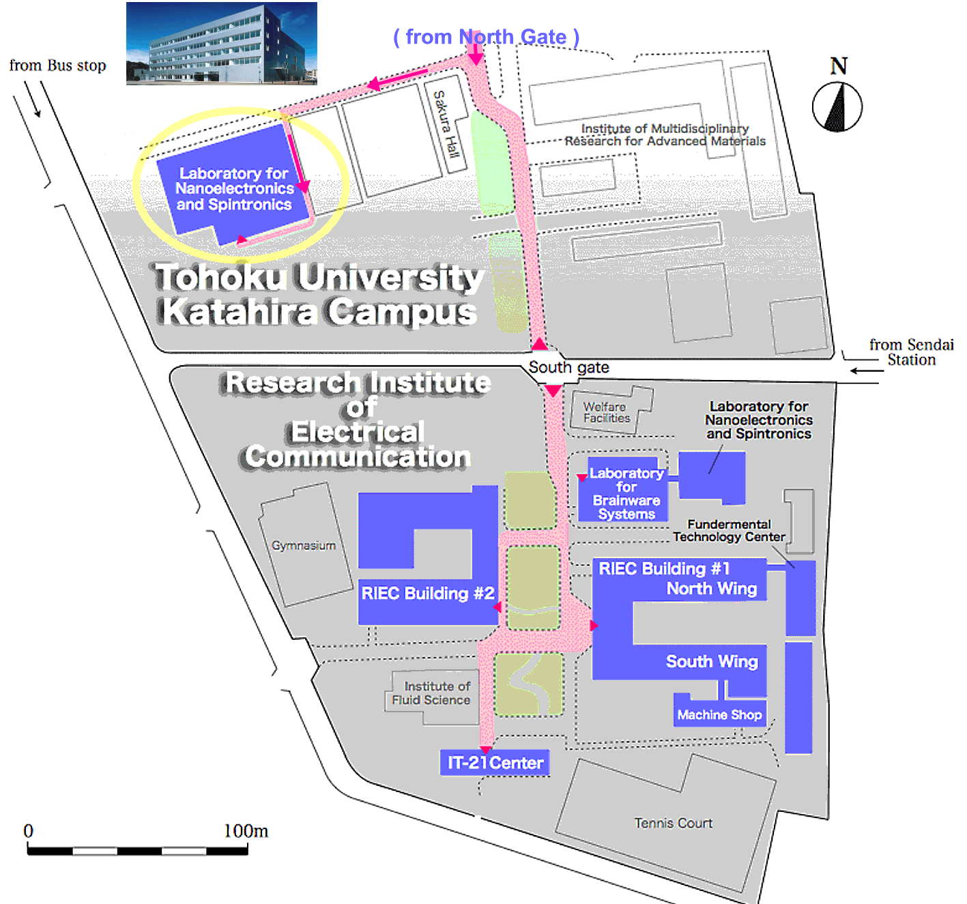
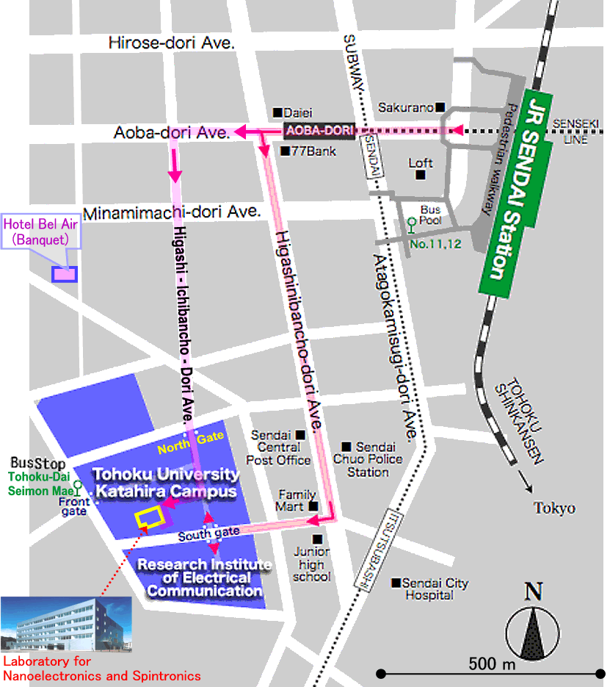

Detailed Map

